**Daily Scrum or Standup Meeting**

Team name: Group 10

Scrum Master: Keldon Boehmer

Date: 10/6/2022

|  |  |  |  |
| --- | --- | --- | --- |
| **Team Member** | **What did you do since the last scrum?** | **What do you plan to do before the next scrum?** | **What obstacles do you have?** |
| Keldon  Boehmer | Completed Sprint Planning meeting document. | Populate database with drinks and ingredients. Create orders model in database. | Weekend plans  Other classes |
| Zach  Harrison | Posted tasks to Github project board with descriptions. | Merge user models to user superclass model. | Other classes |
| Jensen  Judkins | Added functionality to create user and allow user to login. | Research permissions for different user types. Create unit test to test user creation. | Student athlete weekend trip.  Models need to be merged before permissions can be implemented. |
| Noah  Knight | Mapping and forming UI ideas. | Login and user creation page UI set up.  Set up navigation after models merge.  Menu page UI | Models need to be merged.  Drinks and ingredients have been added to database. |
|  |  |  |  |

# Burndown

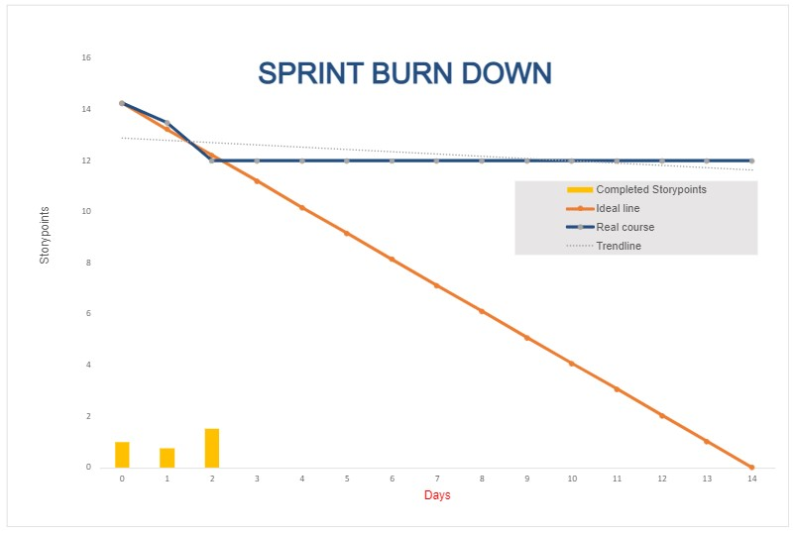

# Screenshot of you project board

